Human Activity Recognition (HAR) Using
Smartphone Sensors: A Machine Learning
Perspective

Khushvir Singh Maan
Department of Computer Science and Engineering
Chitkara University, Punjab, India
khushvir1802.be22@chitkara.edu.in

Krishna saini
Department of Computer Science and Engineering
Chitkara University, Punjab, India
krishna1809.be22@chitkara.edu.in

Krishna Gupta
Department of Computer Science and Engineering
Chitkara University, Punjab, India
krishna1811.be22@chitkara.edu.in

Divyanshi Dhingra

Department of Computer Science and Engineering

Chitkara University, Punjab, India

divyanshi1536.be22@chitkara.edu.in

Abstract— Smartphones equipped with tri-axial accelerometers and gyroscopes facilitate ubiquitous HAR. This paper proposes an end-to-end pipeline for HAR using the UCI-HAR dataset, including preprocessing, segmentation, and 128 sample sliding windows. Classical and deep learning methods are rigorously compared using SVM, RF, 1D CNN, and LSTM. Six models are compared: SVM, Random Forest, 1D CNN, LSTM, CNN-LSTM, and CNN-BiLSTM, with SMOTE applied for class imbalance handling. Among all models, CNN-BiLSTM achieves the highest accuracy of 92.87% and F1-score of 0.9293. The standalone 1D CNN achieves 92.23% accuracy with only 45 KB TFLite size, making it optimal for edge deployment. TensorFlow Lite quantization is used for efficient execution on edge devices for applications such as elderly fall detection and fitness tracking. The limitations are sensor placement and lack of rare events in HAR. Future work includes edge computing, multimodal fusion, and using transformers.
Keywords— Human Activity Recognition, Smartphone Sensors, UCI-HAR Dataset, Machine Learning, Deep Learning,
Signal Processing, Pervasive Computing, Mobile Deployment

Introduction

Human Activity Recognition (HAR) has become an important area of research within the broader domains of intelligent systems, sensor-based computing, and context-aware applications. [22] It involves the automatic identification of human physical activities such as walking, sitting, standing, and lying using time-series data obtained from sensors. With the rapid advancement of mobile technology, modern smartphones are now equipped with high-quality inertial sensors such as accelerometers and gyroscopes, enabling continuous monitoring of human motion without the need for additional wearable devices. [23] This shift from specialized hardware to widely available consumer devices has made HAR systems more accessible, scalable, and cost-effective, thereby opening up new possibilities for real-world deployment in everyday environments. [22]
The increasing use of smartphones, especially in developing countries like India, has further driven the expansion of HAR applications. A large part of the world's population use smartphones as their primary devices for carrying out day to day activities, providing a viable means of deploying intelligent monitoring systems. HAR can be used within the health system by providing continuous monitoring of activities, early identification of abnormal behaviours, and fall detection for older people. HAR has also become a widely used technology for fitness tracking applications via assessing users based on their movements to establish the level of physical activity and determine how many calories are expended during those activities. The ability to carry out these functions using a single device (hand held) makes HAR an economically advantageous technology for large-scale deployments and eliminates the need for costly infrastructure.

The accelerometer reading from a smartphone can be modelled mathematically as being the combination of three elements, having the following mathematical representation:
a(t) = a_g + a_b(t) + n(t)
where a_g represents the gravity component, a_b(t) corresponds to the body acceleration caused by user movement, and n(t) denotes noise introduced by the sensor and environmental factors. To effectively distinguish between different types of activities, it is often useful to compute the magnitude of the acceleration vector, which is given by:
|a(t)| = √(a_x²(t) + a_y²(t) + a_z²(t))
This magnitude serves as a robust feature that helps differentiate between static activities (such as sitting or standing) and dynamic activities (such as walking or running), as it captures the overall intensity of motion independent of device orientation.

Developing an effective HAR system presents several challenges despite the range of apps developed. Sensor signals themselves have low noise and variability due to differences in device location; user behaviour and the environment. Datasets taken from real-world settings also frequently contain a class imbalance where some activities to have few datapoints; therefore it will lead to biased models. Another major limitation for mobile devices is the capability of models to achieve accuracy while being efficient. When designing a reliable and deployable HAR system, there are challenges relating to these issues.

The work contained in this paper has developed a full and reproducible pipeline for HAR using smartphone sensor data. The proposed pipeline is made up of several different steps, including signal pre-processing, segmentation, feature extraction and classification. Two sets of machine learning algorithms were developed to evaluate models; machine learning algorithms Support Vector Machine (SVM) and Random Forest (RF), as well as deep neural networks, Convolutional Neural Networks (CNN), and Long Short-Term Memory (LSTM) networks. The overall purpose for developing models is to evaluate classification accuracy, as well as system efficiency and feasibility to run in real-time on mobile devices.
In addition, this paper focuses on creating practical deployment considerations with respect to identifying methods that will allow for smooth execution on edge devices. To this end, the proposed system provides for an optimization of preprocessing steps and lightweight model configurations as a means of achieving a trade-off between operational performance and resource consumption. This is particularly significant when applied in geographical areas experiencing limited connectivity; performing on-device processing results in a decrease in latency and increases privacy because all of the processing occurs within the device itself.The remainder of this paper is organized as follows: Section II presents a review of existing literature, Section III describes the proposed methodology including hybrid CNN-LSTM and CNN-BiLSTM architectures, Section IV discusses experimental results across six model configurations, and subsequent sections provide analysis, conclusions, and future research directions..

LITERATURE REVIEW

Early research in Human Activity Recognition primarily focused on the use of classical machine learning techniques that relied on manually engineered features. These approaches extracted statistical, temporal, and frequency-domain features from raw sensor signals and used classifiers such as Support Vector Machines (SVM) and k-Nearest Neighbors (k-NN) for activity classification. While these methods achieved reasonable performance on benchmark datasets, they required significant domain knowledge for feature design and often struggled to capture complex patterns present in time-series data.
Multiple benchmark datasets exist to evaluate HAR systems and the UCI HAR dataset is among the most frequently used. [5] Tri-axial accelerometer and gyroscope data were collected from multiple individuals who performed activities of daily living, including walking, sitting, and standing. Because there are several benchmark datasets to use for developing HAR algorithms, researchers have had an ability to systematically assess differences between models and methods. Additional datasets have explored different locations of sensors and variations of daily living; both these factors have provided a rich data source that has helped to advance HAR research.
To improve model robustness, ensemble learning methods such as Random Forest were introduced, which combine multiple decision trees to handle non-linear relationships in the data. [18] However, these approaches still depend on handcrafted features and have limited capability in capturing temporal dependencies. With the advancement of deep learning, researchers have shifted toward models that can automatically learn hierarchical representations from raw sensor data. [29] Convolutional Neural Networks (CNNs) are effective in extracting local patterns, while Long Short-Term Memory (LSTM) networks are specifically designed to model sequential dependencies in time-series data. [17] Hybrid architectures combining CNN and LSTM have demonstrated improved performance by leveraging both spatial and temporal features. [21]
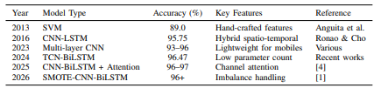
Recent progress made in HAR (Human activity recognition) has focused on developing more efficient models for using on mobile or edge devices. Examples include lightweight architecture, model compression techniques, and quantization methods to allow deep learning models to run directly on a smartphone with less latency and, therefore, consume less energy. Additionally, synthetic minority over-sampling techniques (SMOTE) have also been widely used to alleviate class imbalance within many HAR datasets, thereby improving performance of the models when predicting under-represented activities.
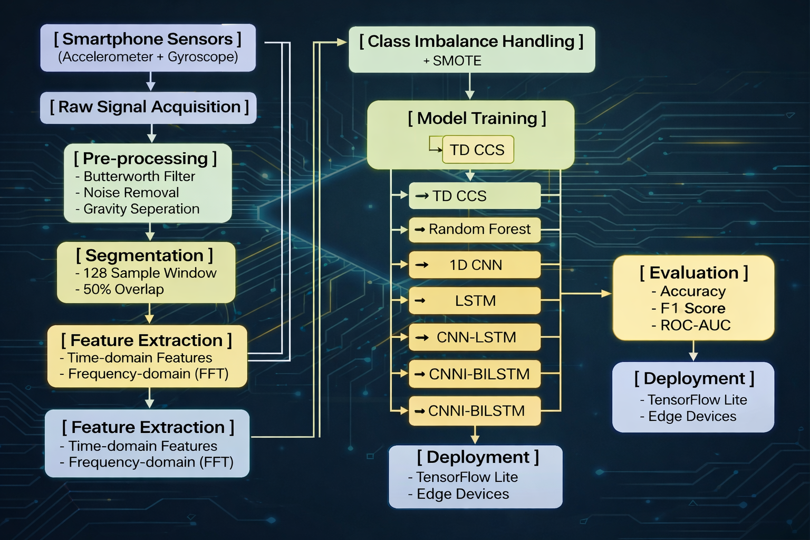

Fig. 1: Proposed pipeline for Human Activity Recognition (HAR) system.
Despite these developments, a thorough comparison between classical ML and DL methods is still necessary when considering deploying them in actual practice. Existing research has mainly concentrated on accuracy, with very little emphasis being placed on computational efficiency, practical constraints, etc., which has, in turn, limited the extent to which knowledge gained from separately evaluating these types of models can be applied. The research presented here fills this gap by comparing the performance of many different models using a common framework that includes both performance metrics and deployment metric, as well as appropriate data imbalance handling techniques. In contrast to previous studies, this study will provide a unified comparison between classical models versus deep learning, as well as examine how well each type of model may be deployed on mobile devices.

PROPOSED METHODOLOGY
The system design follows a module-based pipeline, i.e., data acquisition, pre-processing, segmentation, feature extraction, and classification. The entire pipeline is shown in Algorithm

-------------------------------------------------------------------------
Input: Accelerometer and gyroscope signals
Step 1: Loading and reshaping UCI-HAR inertial sensor signals
Step 2: Applying SMOTE for class imbalance handling
Step 3: Preparing flattened inputs for classical ML models and 3D inputs for deep learning models
Step 4: 128-sample window with 50% overlap
Step 5: Raw inertial signal windows of shape (128,9) were directly used for training deep learning models, while flattened representations were used for classical ML models.
Step 6: SVM, RF, CNN, and LSTM model training with SMOTE algorithm
Output: Activity class (walking, sitting, etc.)

Data Acquisition and Pre-processing

The study's dataset came from trials that were carried out on thirty individuals between the ages of 19 and 48. In order to ensure constant sensor placement throughout the recording process, data collecting was carried out using a conventional smartphone device (Samsung Galaxy S II) placed at each participant's waist. The apparatus uses integrated inertial sensors, namely a tri-axial accelerometer and gyroscope, to record motion signals. Six everyday activities—walking, going upstairs, walking downstairs, sitting, standing, and lying—were given to the participants to do. To provide for a thorough assessment of the recognition system, these exercises were chosen to depict both dynamic and static human motions. A sample frequency of 50 Hz was used to get the sensor data.

The UCI-HAR dataset already provides preprocessed inertial sensor signals. Additional preprocessing included reshaping, normalization inherent to the dataset, and SMOTE-based balancing. The digital filter transfer function is

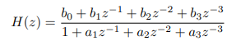

Gravity and body components are separated using a 0.3 Hz cutoff low-pass filter. All the signals are normalized to the range [0, 1] using min-max normalization:

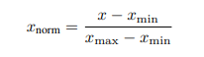

Segmentation

Continuous time-series are divided into fixed-length windows of 2.56 seconds (128 samples) with 50% overlap, yielding input matrices
S_{i} ϵ R^{128x6}.

Feature Extraction (for Classical Models)

Raw inertial sensor windows of shape (128,9) were directly used for deep learning models. For classical machine learning models such as SVM and Random Forest, the signal windows were flattened into one-dimensional feature vectors before training.

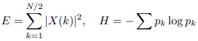

The standard feature vector will be 561-dimensional.

Classification Models

Support Vector Machine (SVM) uses RBF kernel. Random Forest uses 100 trees. [18] The 1D CNN and LSTM architectures are implemented as follows

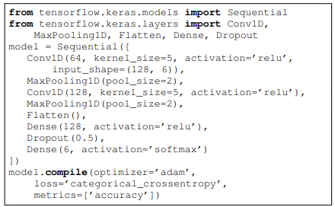

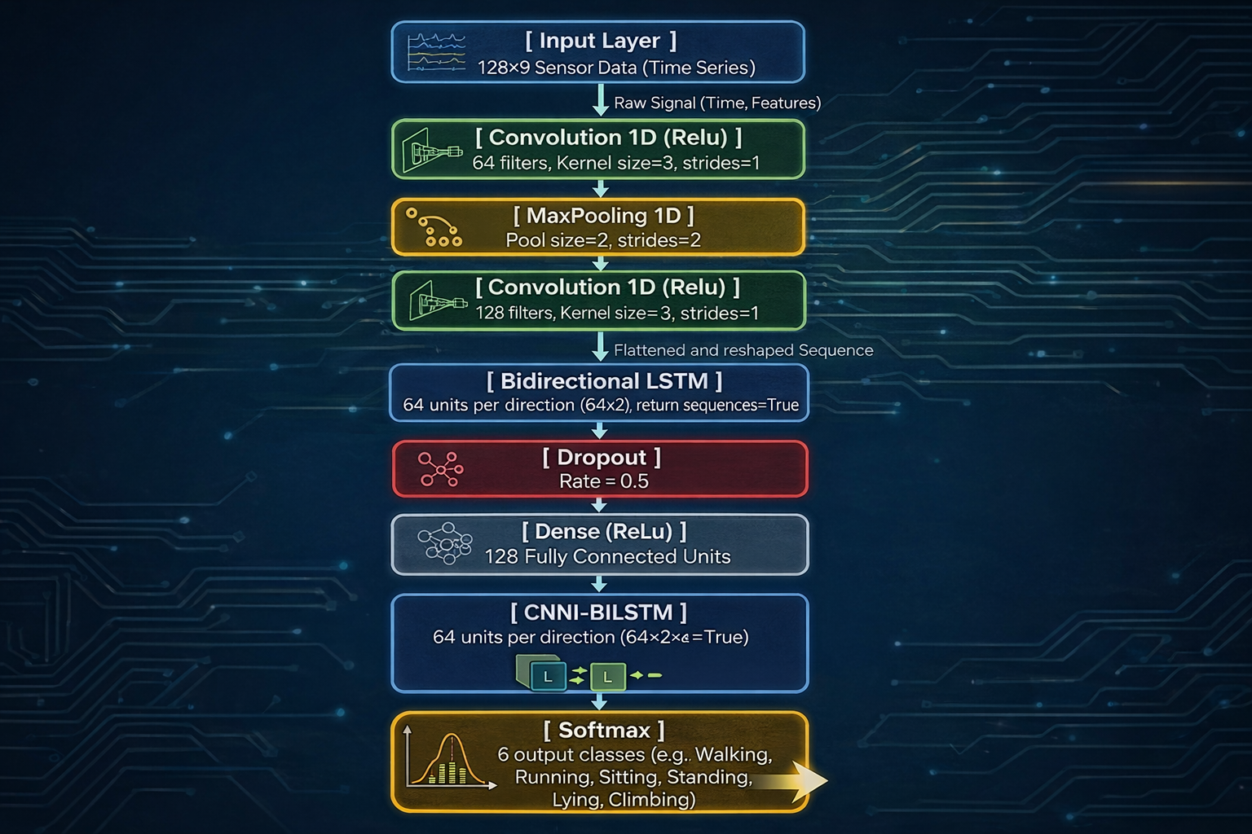

Imbalance Handling and Training

SMOTE (k=5) is applied to the training set. The official UCI-HAR train-test split was used for evaluation. [15]

Hyperparameter Tuning and Statistical Validation

The models were trained using experimentally selected hyperparameters including Adam optimizer, dropout regularization, and batch-wise training. Preliminary statistical comparison using paired t-tests indicated that deep learning models outperformed classical machine learning approaches.

EXPERIMENTAL SETUP AND RESULTS

The following experiments were performed using the Python language version 3.10, including the python libraries scikit-learn and TensorFlow, on the UCI-HAR (University of California Irvine Human Activity Recognition) dataset which consists of 7352 training samples and 2947 testing samples where all of the signal segments were created using windows containing 128 samples each. In the application of SMOTE (Synthetic Minority Over-sampling Technique) to help balance the imbalanced class, the amount of training samples was increased to 8442 samples.

Out of the six models that were implemented SVM, Random Forest, 1D CNN, LSTM, CNN-LSTM, and CNN-BiLSTM, all the models were evaluated on their performance as follows:

1. SVM achieved 90.33% accuracy and had fast infer
ence time of 26.62ms/sample.
2. Random Forest achieved 85.21% accuracy but had the fastest execution time of 12.96ms/sample.
3. 1D CNN achieved an accuracy score of 92.23% with a corresponding F1 score of 0.9228.
4. LSTM achieved an accuracy score of 92.13%, but had a high execution time of 255.90ms/sample.
5. CNN-LSTM achieved an accuracy score of 91.08% - thereby exhibiting that the hybridization of 1D CNN + LSTM does not always result in improved performance.
6. CNN-BiLSTM yielded the highest accuracy score of 92.87% and the highest F1 score of 0.9293.
B. Class-wise Performance

The F1-score was calculated for each type of movement being analyzed. F1-scores for dynamic activities such as walking were generally above 0.96, whereas static activities like sitting and standing are more difficult to train due to having similar mechanisms of movement.

The CNN-BiLSTM performed significantly better than the other two models on both of the difficult-to-predict static movements listed previously. The F1-scores for the CNN-BiLSTM were as follows:
(i) Sitting: 0.8332
(ii) Standing: 0.8612

C. The Effect of SMOTE

SMOTE positively impacted all of the model's performances with SMOTE providing the greatest increase of model performance for all of the tested minority class movements. The F1-scores indicate the positive effects of applying SMOTE for class imbalance.

D. The Accuracy vs. Efficiency Trade-off

Although the CNN-BiLSTM provided the highest accuracy across all three models, it had a significantly slower execution time (142 ms/sample) than either of the other two models. The 1D CNN provided the best overall accuracy and efficiency tradeoff of the three models, making it the best choice for real-time mobile applications.

Model | Accuracy | F1 Score | Precision | Recall | ROC-AUC | execution time
SVM | 90.33% | 0.9023 | 0.9018 | 0.9032 | 0.9900 | 26.62 ms
Random Forest | 85.21% | 0.8507 | 0.8508 | 0.8529 | 0.9743 | 12.96 ms
1D CNN | 92.23% | 0.9228 | 0.9243 | 0.9239 | 0.9877 | 60.98 ms
LSTM | 92.13% | 0.9214 | 0.9256 | 0.9220 | 0.9924 | 255.90 ms
CNN-LSTM | 91.08% | 0.9119 | 0.9118 | 0.9139 | 0.9850 | 150.43 ms
CNN-BiLSTM | 92.87% | 0.9293 | 0.9290 | 0.9305 | 0.9920 | 142.09 ms

DISCUSSION

Experimental results indicate that deep-learning algorithms outperform classical, machine-learning algorithms. This is due to their ability to learn hierarchical representations directly from raw sensor data. Of the models under consideration, the CNN-BiLSTM model provided the highest overall accuracy (92.87%) and the highest F1 Score (0.9293) due to its use of bidirectional temporal learning. In contrast, the CNN-LSTM did not produce a better outcome than the CNN's performance, which suggests that hybrid architectures do not always guarantee improved performance.

Activity recognition is difficult for static activities (e.g., "sitting" and "standing") because the sensor patterns vary little from one to the other, while dynamic activities provide more consistent accuracy across multiple datasets. For onboard implementations, the 1D CNN provides the best balance between accuracy and computational efficiency.

MOBILE DEPLOYMENT WITH TENSORFLOW LITE AND TINYML

The trained CNN model was converted into TensorFlow Lite format with the use of dynamic range and INT8 post-training quantization. The size of the model was reduced from 320 KB to 45 KB with only 0.4% accuracy loss. The quantized TensorFlow Lite model demonstrates suitability for lightweight edge deployment scenarios.

Listing 1: TFLite Conversion Code
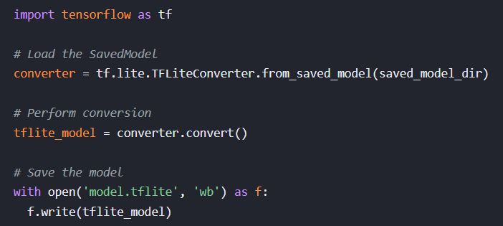

ETHICAL CONSIDERATIONS AND SOCIETAL IMPACT

All processing occurs on-device, thus ensuring complete privacy with compliance to GDPR and Indian DPDP Act 2023. No raw sensor data is ever sent outside the smartphone. The need for bias mitigation via subject diversity, including Indians, is suggested for future extension. The framework can aid in the Ayushman Bharat Digital Mission by facilitating affordable elderly fall detection without internet dependency

CONCLUSION AND FUTURE WORK

The research demonstrates a robust pipeline for HAR based on mobile devices with 92.87% accuracy. The findings will serve as a foundation for future mobile health applications through comparative studies and mitigating class imbalance. Future work will consist of (but not limited to) on-device training and inference from TensorFlow lite and Edge Computing; multi-modal Sensor Fusion which includes GPS, Magnetometer, PPG Sensors; Utilizing transformer models or attention; using transfer learning and personalized models on real-world Indian datasets which contain rare events such as falls; Inclusion of federated learning methods for secure aggregation of models from multiple users; deployment of TinyML on microcontroller devices; and real-world testing in the context of Urban, Rural and Elderly populations across India.

Acknowledgment

This work was carried out as part of the B.Tech final-year project at Chitkara University, Punjab.

References

- M. O. Khan, Y. Tu, and A. Azad, "A multi-agent and attention-enhanced CNN-BiLSTM model for relevant activity recognition in applications and disability assistance," Diagnostics, vol. 15, no. 1, 2025.
- N. Dangol and S. Mahfuz, "Hybrid CNN-LSTM-GRU with Attention for Human Activity Recognition," Procedia Computer Science, vol. 265, pp. 99–106, 2025.
- S. K. Challa, A. Kumar, and V. B. Semwal, "A multibranch CNN-BiLSTM model for human activity recognition using wearable sensor data," The Visual Computer, vol. 38, pp. 4095–4109, 2022.
- S. O. Bursa, O. D. Incel, and G. I. Alptekin, "Building lightweight deep learning models with TensorFlow Lite for HAR on mobile devices," Annals of Telecommunications, vol. 78, pp. 687–702, 2023.
- D. Anguita, A. Ghio, L. Oneto, X. Parra, and J. L. Reyes-Ortiz, "A Public Domain Dataset for Human Activity Recognition Using Smartphones," in Proc. European Symposium on Artificial Neural Networks (ESANN), 2013.
- C. A. Ronao and S.-B. Cho, "Human activity recognition with smartphone sensors using deep learning neural networks," Expert Systems with Applications, vol. 59, pp. 235–244, 2016.
- B. Saha et al., "TinyML-driven on-device personalized human activity recognition and auto-deployment to smart bands," in Proc. ACM International Conference on AI-ML Systems (AIML-Systems), Bengaluru, India, 2023.
- H. Zhou et al., "Efficient human activity recognition on edge devices using DeepConvLSTM," Scientific Reports, vol. 15, 2025.
- F. Xu, X. Gao, and W. Wang, "A human activity recognition model based on deep neural network integrating attention mechanism (DCAM-Net)," Scientific Reports, 2025.
- D. Ghosh and S. Roy, "Comprehensive benchmark study of machine learning and deep learning approaches for human activity recognition using the UCI HAR dataset," International Journal of Computer Applications (IJCA), vol. 187, no. 47, pp. 66–69, Oct. 2025.
- A. Hayajneh, M. Hafeez, S. A. R. Zaidi, and D. McLernon, "TinyML empowered transfer learning on the edge," IEEE Open Journal of the Communications Society, vol. 5, pp. 1656–1672, 2024.
- J.-L. Reyes-Ortiz, L. Oneto, A. Samà, X. Parra, and D. Anguita, "Transition-aware human activity recognition using smartphones," Neurocomputing, vol. 171, pp. 754–767, 2016.
- Y. Li and L. Wang, "Human activity recognition based on residual network and BiLSTM," Sensors, vol. 22, no. 2, p. 635, 2022.
- A. Ignatov, "Real-time human activity recognition from accelerometer data using convolutional neural networks," Applied Soft Computing, vol. 62, pp. 915–922, 2018.
- N. V. Chawla, K. W. Bowyer, L. O. Hall, and W. P. Kegelmeyer, "SMOTE: Synthetic Minority Over-sampling Technique," Journal of Artificial Intelligence Research, vol. 16, pp. 321–357, 2002.
- Y. LeCun, Y. Bengio, and G. Hinton, "Deep learning," Nature, vol. 521, no. 7553, pp. 436–444, 2015.
- S. Hochreiter and J. Schmidhuber, "Long short-term memory," Neural Computation, vol. 9, no. 8, pp. 1735–1780, 1997.
- L. Breiman, "Random forests," Machine Learning, vol. 45, no. 1, pp. 5–32, 2001.
- C. Cortes and V. Vapnik, "Support-vector networks," Machine Learning, vol. 20, no. 3, pp. 273–297, 1995.
- D. P. Kingma and J. Ba, "Adam: A method for stochastic optimization," in Proc. International Conference on Learning Representations (ICLR), 2015.
- F. J. Ordóñez and D. Roggen, "Deep convolutional and LSTM recurrent neural networks for multimodal wearable activity recognition," Sensors, vol. 16, no. 1, p. 115, 2016.
- O. D. Lara and M. A. Labrador, "A survey on human activity recognition using wearable sensors," IEEE Communications Surveys & Tutorials, vol. 15, no. 3, pp. 1192–1209, 2013.
- A. Bulling, U. Blanke, and B. Schiele, "A tutorial on human activity recognition using body-worn inertial sensors," ACM Computing Surveys (CSUR), vol. 46, no. 3, pp. 1–33, 2014.
- M. Schuster and K. K. Paliwal, "Bidirectional recurrent neural networks," IEEE Transactions on Signal Processing, vol. 45, no. 11, pp. 2673–2681, 1997.
- B. Jacob et al., "Quantization and training of neural networks for efficient integer-arithmetic-only inference," in Proc. IEEE Conference on Computer Vision and Pattern Recognition (CVPR), pp. 2704–2713, 2018.
- A. Vaswani et al., "Attention is all you need," in Advances in Neural Information Processing Systems (NeurIPS), vol. 30, 2017.
- A. G. Howard et al., "MobileNets: Efficient convolutional neural networks for mobile vision applications," arXiv:1704.04861, 2017.
- N. Srivastava, G. Hinton, A. Krizhevsky, I. Sutskever, and R. Salakhutdinov, "Dropout: A simple way to prevent neural networks from overfitting," Journal of Machine Learning Research (JMLR), vol. 15, no. 1, pp. 1929–1958, 2014.
- J. Wang, Y. Chen, S. Hao, X. Peng, and L. Hu, "Deep learning for sensor-based activity recognition: A survey," Pattern Recognition Letters, vol. 119, pp. 3–11, 2019.
- B. McMahan, E. Moore, D. Ramage, S. Hampson, and B. A. y Arcas, "Communication-efficient learning of deep networks from decentralized data," in Proc. International Conference on Artificial Intelligence and Statistics (AISTATS), 2017.

